Security group rules  
  
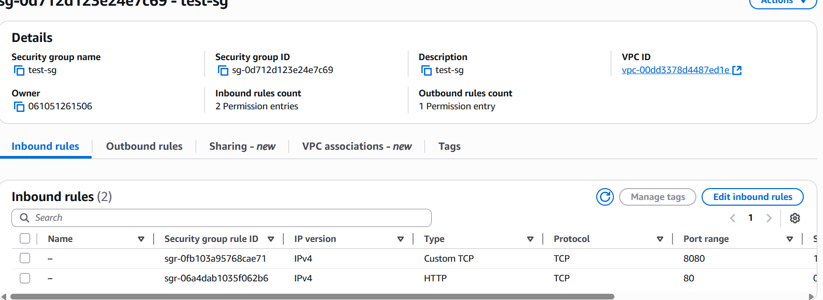

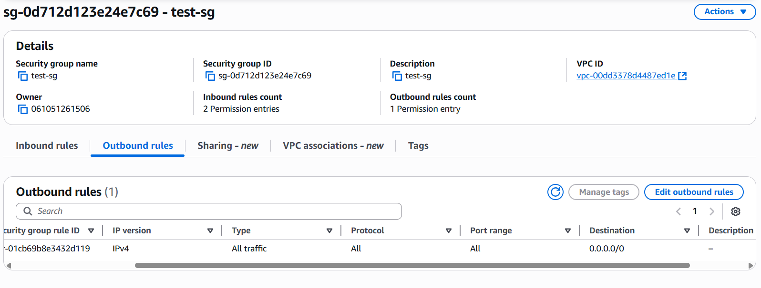  
  
  
Ec2 instance running  
  
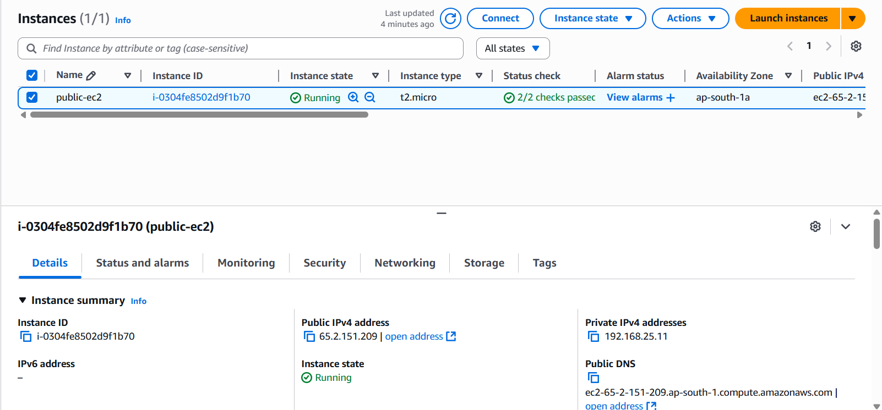

1. SSH connection to the EC2 instance.  
     
   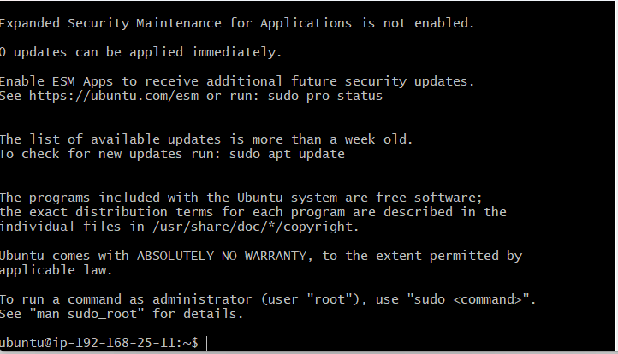
2. Browser output showing Nginx on port 80 and Tomcat on port 8080

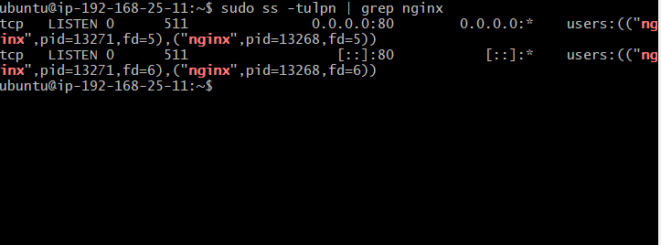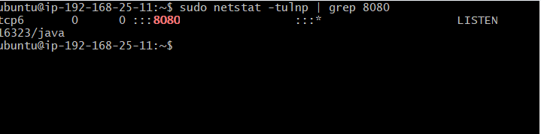

2.Commands used for installation and server configuration.

**Nginx conf**

sudo apt update -y

sudo apt install nginx -y

sudo systemctl start nginx

sudo netstat -tuln | grep 80  
  
 **Tomcat configuration**

sudo apt update -y

sudo apt install tomcat10 tomcat10-admin -y

sudo systemctl start tomcat10

sudo systemctl enable tomcat10

sudo systemctl status tomcat10

sudo netstat -tuln | grep 8080  
  
  
  
Q) Why multiple ports were opened?

Ans) Each application requires a unique port to operate independently and avoid conflicts. Opening multiple ports ensures both services can run simultaneously and be accessed from outside the instance.

Q) How security groups help in controlling access to AWS resources?

Ans)Security Groups helps AWS resources from unauthorized access while allowing legitimate connections required for application functionality.